Git

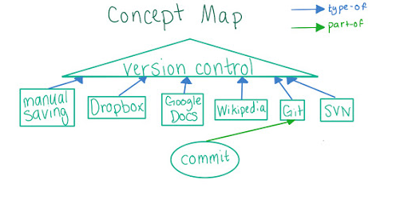

A “commit” is conjunction of saved files in a repository

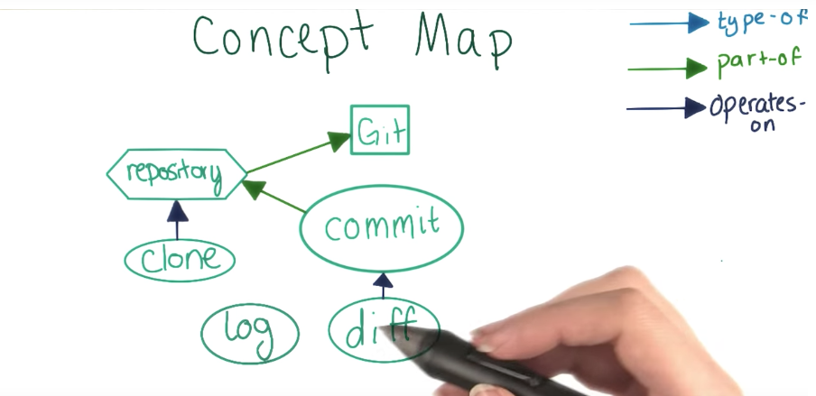

Git Commands

git clone “url” -> clone a repository in a folder

git log -> give logs of the repository (list of commits)

git diff “first_commit_id” “second_commit_id” -> give differences between each commit of git

git config --global color.ui auto -> Getting colored output on logs and diff for git

git checkout “commit_id” -> reverse the files to the commit of that id for checking them out. This command erase the other commits after. To return to the newer commits it is needed to remember the last id commit with the last change.

git init -> initiliaze a repository

git status -> give status of the repository